FY23 Annual Report
Community & Neighborhood
Development Division:

Areas of Focus:
Community Betterment
Family Support
Financial Stability
Student Development

Community Betterment:

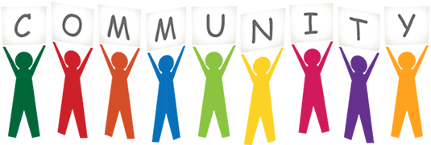

Crime Stoppers:
The Greater Springfield Area Crime Stoppers Program encourages members of the community to assist local law enforcement agencies in the fight against crime by overcoming the two key elements that inhibit community involvement: fear and apathy. Crime Stoppers relies on cooperation between the police, the media, and citizens to provide anonymous information about crime and criminals in the Greene County area with a major focus on crime within Springfield city limits. The program is designed to develop information used to solve felony crimes. Cash rewards of up to $1,000 are available for tips that directly lead to a felony arrest OR seizure of a felony amount of drugs. All tip rewards are provided at the discretion of the civilian advisory board. The Crime Stoppers program utilizes local law enforcement for tip investigations but there is no contact information obtained for the Tipster, no caller ID, and the conversation is not recorded. All tip submissions are kept completely anonymous by using a tip hotline number, a secure online website or a discreet P3 app available for smart phones.
FY23 was a year of growth, as the program got a new coordinator and 3 new advisory board members. Despite a bit of a learning curve with so many new members, the group has worked hard to promote the Crime Stoppers program through increased participation at community events and social media activity. Crime Stoppers’ online presence has grown tremendously and is helping to spread the word about the program. Crime Stoppers is expecting even more growth in the new fiscal year with board member recruitment and fundraising.
- 1,356 tips were received
- 1,084 tip follow-ups were made
- Approximately $1,000 was paid out to 17 tipsters who provided valuable information leading to felony arrests/charges filed

Community Collaboratives:

- In April, The Child Abuse and Neglect Collaborative hosted their first in-person Go Blue kickoff event since COVID. Over 100 people attended the event hosted at the Springfield Art Museum. Several media outlets were present, and speakers included Executive Directors of community organizations, a Youth Advocate who shared stories of survivor resilience, and the Mayor of Springfield who presented a proclamation in honor of the day. At the conclusion of the event participants planted a pinwheel garden outside.
- Environmental Sustainability hosted several educational events during 2023, including a presentation by environmental justice experts from the EPA and an expert on paint recycling efforts in Missouri. In addition, the collaborative hosted tours of Jordan Creek and the Noble Hill Sanitary Landfill, both attended by approximately 15 community members each.
- As part of the Food Collaborative, Double Up Food Bucks, a grant through the USDA, has continued this year at Springfield Farmer’s Markets: C-Street Market, Farmer’s Market of the Ozarks, and the Greater Springfield Farmer’s Market. SNAP participants can visit these markets and get free tokens to purchase locally grown fruits and vegetables. In addition, CPO was the recipient of a USDA Local Food Purchasing Assistance Grant that will provide over a million dollars in funding to purchase and distribute locally grown food to underserved communities in 17 counties in SW Missouri. CPO is working closely with the Food Collaborative to plan and implement this grant.
- The Housing Collaborative hosted a Fair Housing 101 event in April for social service providers and case managers. The event was a huge success with 69 Individuals in attendance, 6 speakers, and 32 agencies represented. Speakers discussed fair housing laws, information on advocating for individuals with disabilities, information about One Door, current opportunities around financial literacy education for clients, and more. In addition, in spring 2023 the Housing Collaborative’s Nuisance Property Committee produced a recommendation report that was presented to City Council; the collaborative is committed to continuing to address this issue.
- Let’s Go Smart continued to host quarterly Walk and Talks this year. Highlights included a “ride and talk” with the bus system focusing on rideability and accessibility issues. In addition, this past year collaborative members toured the Moon City Neighborhood, viewing neighborhood artwork and learning about infrastructure plans that will increase pedestrian safety. In June, the collaborative also partnered with the Boys and Girls Club of SGF to teach a bicycle safety class to 10 local children from two different BGC campuses. Students spent the first half of the class learning bicycle safety on a marked parking lot course, then got to ride the South Greenways trail for the second half of the class.
- This past year a new collaborative formed, the Health Equity Collaborative. The collaborative has nearly 20 organizations and three active subcommittees working on a three-year action plan to address health inequities in Greene County.

- The Early Care and Education collaborative hosted several successful events including the Called to Care Conference, the Day of Play, several film screenings, and legislative action days. The collaborative also worked to advance workforce development issues in collaboration with the Chamber of Commerce. Additionally, the regional hub created a new blog to be a resource for providers and families in three counties, sharing upcoming events, trainings, and announcements.
- 1,462.50 volunteer hours
- 125 unique, active members
- Organizations represented:
  - CAN – 27 organizations
  - Environmental – 19 organizations
  - Food – 17 organizations
  - Housing – 29 organizations
  - Let’s Go Smart Transportation Collaborative– 16 organizations
  - Health Equity: 18 organizations
  - Early Care and Education: 29 organizations
  - Total unique organizations: 63

Neighborhood Education/Support:
Neighborhood Clean-ups:
Grant Beach Neighborhood kicked off our Fall 2022 clean-up season strong on September 27th, collecting nearly 20 tons of trash in 7 hours. Meador Park closed out the Fall season on November 10th. While most neighborhoods saw a slight decrease in the amount of trash they disposed of, it was still a successful clean-up season that disposed of over 79 tons of trash. Neighborhoods faced a few challenges including dropping temperatures, rainstorms, and a lack of volunteers, but worked through them to finish strong. Bradford Park hosted a clean-up this year after not being able to have one in the previous year, and Oak Grove was able to take advantage of their new partnership with Enterprise Lanes and host their clean-up in the business parking lot!
Heart of the Westside Neighborhood kicked off our Spring 2023 clean-up season on March 28th and Bissett closed out the season on June 8th. While the amount of trash collected this year did decrease for the spring season as well, the program still helped neighborhood residents dispose of over 130 tons of trash. Westside Neighborhood nearly doubled the amount of trash they had collected in the previous year.
Woodland Heights Neighborhood Clean-Up was our largest one this year, collecting 41.5 tons of trash over two days. Grant Beach Neighborhood Clean-Up was our second largest one this year, collecting 19.32 tons of trash over two days. Overall, this year, 222 tons of trash was taken to the landfill, 17 tons of scrap metal was recycled, 111 waste and 37 yard waste dumpsters were filled, and 1,570 households were served. We had an amazing 287 volunteers give over 1,386 hours of their time.

Electronics Recycling:
Community Partnership of the Ozarks received a grant from the Ozarks Headwaters Recycling & Materials Management District, which allowed us to offer one free recycling of a TV or computer to each household in Springfield. This service was provided through vouchers included on the postcards that we mailed out to residents that advertised the neighborhood clean-ups. Using these vouchers, residents were able to recycle 255 TVs and 59 computers that would have otherwise cost money to recycle or would have ended up at a landfill.

Springfield Tool Library:
This year, the Springfield Tool Library celebrated its 10th anniversary and experienced amazing growth. A larger shed was placed at the O’Reilly Center for Hope to better store and organize the growing inventory. The inventory was updated, and a new tracking system was put in place. Currently, the Tool Library has over 270 tools in its inventory. In addition, the Tool Library added over 60 new members this year, putting our current number at 185 active members, 5 of which are lifetime members. We were able to process 512 separate transactions: 261 item checkouts, 108 item renewals, 355 item returns, 147 membership extensions, and 88 membership fees. The Springfield Tool Library has served as a valuable resource to the Springfield community this year.

Fix-It Fairs:
The quarterly Fix-it-Fair has always been an exciting opportunity for CPO and the Midtown Carnegie Library to help the community by gathering volunteers to assist in repairing broken valuables. We hosted 3 Fix-it-Fairs this year in which 7 different volunteers gave 44 hours of their time to help over 75 people repair their broken lamps, radios, blenders, can openers, clothing, and other household items! Fix-it-Fairs are a fun and engaging way for us, our partner, and volunteers to give back to the community in a tangible way.

National Night Out:
After a two-year hiatus due to COVID, we were able to host National Night Out once again in August. NNO is an evening of free crime prevention and safety education, interaction with local first responders, and fun and engaging activities for the whole family. After 2 years without NNO, the event was back and better than ever. It was held at Meador Park on one of the hottest days of the year, but people still came out and had a blast. Springfield Police Department, for the third year in a row, walked away the campions of the Police and Fire softball game. Thanks to Air Services, our signature sponsor, and great partnerships with the City of Springfield, Police, Fire, Parks, Ozark Mountain Popcorn, and Convoy of Hope, National Night Out 2022 went down in the books as a success. Approximately 1,000 residents participated in NNO 22.

NOVAs:
We hosted the 16th annual NOVA event at the Oasis Hotel & Convention Center in December. This year, our theme was Change Makers: Leading the Way in Creating Positive Change One Neighborhood at a Time. We chose this theme because we believe that neighborhoods, and the people that make them up, are working tirelessly to make Springfield a better place to live one neighborhood at a time, and together, we are collectively creating positive change in our community.
We were able to celebrate 170 of our community members at this event. Joe Daues, CEO of Breast Cancer Foundation of the Ozarks, emceed the event, while Rusty Worley provided the keynote speech. He shared his heart for neighborhood involvement and encouraged neighborhoods in building rapport and connections with their fellow neighbors.
Our Reaching for the Stars award, which was given to an organization that had a profound impact on our neighborhoods in the past year, was awarded to Bass Pro Shops. They have become an amazing partner to neighborhoods through the creation of the 5K Cheering Challenge and financially supporting neighborhoods. Our Inspiration Award, a new award we introduced this year, that was sponsored by University of Missouri Extensions, was awarded to a neighborhood association that inspires others in our community to create lasting change through innovation. This award was given to Woodland Heights because they have demonstrated what an amazing neighborhood association can accomplish when they work together.

Leadership Summit:
The 3rd annual Leadership Summit for neighborhood association board members was held in March and had 34 in attendance. Attendees were educated and equipped to better serve their neighborhoods through presentations and discussion. Councilman Craig Hosmer opened the summit with a presentation on how neighborhoods can advocate for their needs and use their voice to make change. Sarah Kerner, a local attorney, shared information on board conduct and ethics, particularly as they relate to bylaws. Darline Mabins, a local DEI champion, shared ways that neighbors can embrace diversity, work to include everyone, and create a more equitable neighborhood. She provided ideas for how neighborhoods can create a space that is welcoming to all. Chance Parrish, a Woodland Heights board member, shared his experience about how his association welcomed and engaged him into the neighborhood and how this helped him grow his neighborhood’s watch program and create a safer, more engaged neighborhood. David Burton, a Community Development Specialist with MU Extension, shared about how working with the diversity of strengths and talents brings neighbors to the table and gets them working together as a team. He encouraged attendees to genuinely get to know the people in their community. Although we hit a few snags along the way with technology, all the attendees seemed to enjoy the community and connection that was built. The Leadership Summit was an amazing opportunity to invest in our neighborhood members.

Springfield Neighborhood Kickball Championship:
The 2nd annual neighborhood kickball tournament was a big success! 75 people attended and/or participated in the kickball tournament that took place at Meador Park in April! Throughout the year, 8 different neighborhood associations participated in the planning and facilitation of this fun and unique event. The neighborhoods represented were Meador Park, Rountree, Doling, Woodland Heights, Galloway, Brentwood, Delaware, West-Central.

Family Support:
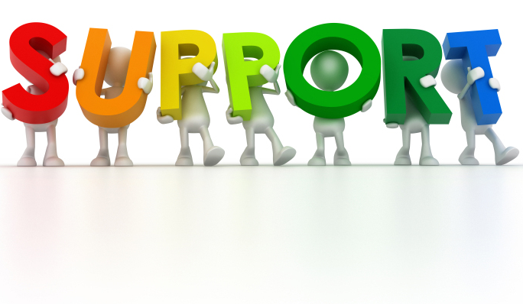
Community Social Work:
The mission of social work is to enhance human well-being while meeting basic needs and empowering those who are oppressed, living in poverty and vulnerable. Social workers promote not only human well-being, but also the well-being of a community. This is done through advocating for social and economic justice, promoting healthy coping skills, assessing client’s needs and coordinating available services needed, and empowering individuals and families through education and resource referrals.

Crisis Intervention/Family Support Services:
- 284 individuals served
- 156 families served
- 316 community referrals made
- 1,068 family contacts made (phone/email/office visits/home visits)
- 11 clients served through case management

Emergency Assistance:
- 21 individuals/families assisted with Cancer Fund
- 18 individuals/families assisted with Caring Communities Emergency Fund
- 5 individuals/families assisted with Community Emergency Fund

Social Work Interns:
This year we had the pleasure of having 4 social work interns through Missouri State University and 2 through Evangel University. They completed their practicums through our community-based social work, school-based social work, and community development programs. During their time with us they assisted with a wide variety of tasks and projects. They provided case management for families, assisted with crisis intervention, facilitated a skill-building middle school group, participated in neighborhood clean ups, attended coalition meetings, planned a social services training, created a homeless services task force and much, much more. We are incredibly appreciative of the work they did and the impact they made during their time at CPO!
- 6 BSW practicum students
- 2,400 total hours given
Midtown Library Partnership:
We completed our second year of partnering with the Midtown Library, providing resources and support for their patrons. Our community-based social worker has a weekly on-site presence from 2-4 every Wednesday and is available for any/all patron social work needs. We saw a large uptick in participation this year and we were able to assist 58 patrons in FY23. Assistance ranged from providing community resources, helping with applications for benefits, answering questions, and providing a listening ear.

Transportation Support Project:
This year we were awarded not one, but two more rounds of funding from the Community Foundation of the Ozarks’ Let’s Get to Work program! In total, we received $55,000 to help our community. This funding is meant to support workers and job seekers who face transportation barriers that affect their ability to get hired or maintain their current jobs. It can be used to meet needs such as car repairs, licensing fees/taxes, car insurance, gas cards, car payments, bus passes and even car down payments. We are still working to spend the remainder of our second round of funds, but in FY23, we were able to assist 44 clients in 3 counties. Prior to the creation of this program, transportation related barriers were an overlooked issue for many in our community. Clients have been incredibly grateful for the assistance provided and often highlight the relief it brings to them and their families!
Testimonials/Quotes from Transportation Clients:
“I was able to get my car going and have a set schedule for work, not just when I could make it in”
“This help has allowed me to provide safe transportation for my newborn & myself to work. I was so happy to learn that the help would cover anything my car needed & cannot thank CPO enough for their assistance! The gas card also helped me to get my baby to his specialist in Kansas City, which took a lot of financial pressure off.”
“It has helped us to get back on our feet, I was out of work for a few weeks and my husband has been out of work due to major health issues so we're behind on bills. With their help I'm able to breathe and get back on track”
“I was behind on my car payment and car insurance because my husband lost his job and was not hired until 4 months later. I must have a car to get my kids the school, they are unable to ride the bus until next year. I am extremely grateful for you helping my family during this tough time.”

Affordable Housing Supportive Services:
Fulbright Springs:
Fulbright Springs is a single-family housing development (71 homes) designed to provide safe, affordable, and quality housing for families in our community. The concept driving the program is that affordable housing is about more than a roof over someone’s head — it’s about creating solutions that help improve lives and strengthen communities. Our partnership with this innovative model allows us to offer an array of supportive services, education, and neighborhood development through an on-site social worker. The goal of these services, in conjunction with the long-term homeownership option, is to equip families with the tools needed to attain stability, connect to the community, and improve on each aspect of healthy family functioning.
Family Support:
- The community coordinator provided an atmosphere of trust and respect while building strong relationships with residents. As the coordinator built these relationships, she assisted 4 residents throughout the year with rent referrals, community resources, tax assistance, and other documents such as food stamp applications.
- The community coordinator was able to help a total of 193 residents (duplicated) throughout the year by providing bi-weekly produce that helped supplement grocery expenses.

Community Garden:
The purpose of the FBS community garden is to promote healthy eating by enlisting the residents to care for and maintain the garden, and then to enjoy the benefits of the fresh produce. Living on a tight budget doesn’t always allow families to eat as healthily as they would like. With the community garden on-site, and free to the residents, it provides them with the option of eating items that are fresh and healthy, as well as teaching them the basics of gardening. This year, the following items were planted in the garden: tomatoes, peppers, zucchini, and asparagus.

Community Events/Activities:
Ongoing community events and activities are provided to FBS residents free of charge. These events occur two-three times per month and range from fun family-friendly activities, activities that get residents up and moving, educational events, and connections to local agencies and organizations. Events such as meal planning kits, a neighborhood cleanup, budgeting and credit building classes, a soup swap event, a neighborhood-wide garage sale, an Easter event, a Mother’s Day event, a Mental Health Awareness Day event, and homeownership classes. These activities engaged approximately 20 households over the last year.

Community Share Shelf:
Through collaboration with the Community Coordinator and FBS residents, a ‘share shelf’ was created in March 2018. The residents wanted an opportunity to help/share with each other. A shelving unit was placed for easy storage of hygiene items, food supplies, and clothes in the computer lab area of the community building where residents can anonymously pick up and drop off supplies. In FY23, 40 residents benefited from, and donated to, the share shelf.
Produce Distribution:
In July 2016, Ozarks Food Harvest began partnering with the Fulbright Springs community to provide approximately 800lbs of fresh produce on a weekly basis to residents, free of charge. The Community Coordinator has been able to provide pick-up (in the community room) and home delivery to residents who work or are disabled during produce distribution. A total of 193 (duplicated) residents were served this year.
Doling Landing: Oct. 22-June 23
Doling Landing, the newest affordable housing partnership which started in October of 2022, is a single-family housing development (24 homes) designed to provide safe, affordable, and quality housing for families in our community. The concept driving the program is that affordable housing is about more than a roof over someone’s head — it is about creating an environment to strengthen communities. Our partnership with this model allows us to not only have events but encourage the community to come together and care for each other. Through events held in the community rooms, neighbors can enjoy fun activities, learn a new skill, and get to know one another.
Community Events/Activities:
Ongoing community events and activities are provided to Doling residents free of charge. These events occur monthly and range from fun family-friendly activities, activities that get residents up and moving, educational events, and connections to local agencies and organizations. The following events/activities took place over the last 8 months: meal planning kits, pie social, soup swap, budgeting and credit building classes, coffee and conversation, holiday food baskets, Easter event, Mother’s Day event, and a Mental Health Awareness Day event. These events/activities engaged approximately 21 households.
Woodfield Park, Oakwood Place and Plymouth Landing Apartments:
Woodfield Park, Oakwood Place and Plymouth Landing are apartment developments designed to provide safe, affordable, and quality housing for families in our community. The concept driving the program is that affordable housing is about more than a roof over someone’s head — it is about creating an environment to strengthen communities. Our partnership with this model allows us to not only have events but encourage the community to come together and care for each other. Through events held in the community rooms, neighbors can enjoy fun activities, learn a new skill, and get to know one another.

Community Events:
Ongoing community events are provided to Woodfield Park, Oakwood Place and Plymouth Landing residents free of charge. These events occur every other month at Woodfield Park, and quarterly at Oakwood Place and Plymouth Landing. Each event ranges from family-oriented activities, educational opportunities to fun socializing events. The newest Community Coordinator joined the organization last fall, allowing the first planned gatherings to be social events and holiday gift baskets for the Thanksgiving season. The holiday baskets contained all the food needed to prepare a yummy holiday meal. 46 baskets were prepared and given out to residents across these three apartment complexes. The new year brought more educational and informational events/activities which included local organizational resource highlights, credit score information, and quarterly newsletters. These events served approximately 50 families over the last year.
Westport Park Apartments:
In November 2022, the Community Coordinator shopped, assembled, and distributed 22 free Thanksgiving food baskets to families at Westport Park Apartments. Many residents found themselves in need of a little extra help during the holiday season and were so appreciative of the support. In addition, educational and informational workshops were hosted in the community room throughout the spring, they included a presentation from a local community-based organization and a credit 101 class. A total of 25 residents attended these events/activities.

School Based Social Work:
During the 2022-2023 school year, all SPS buildings had social work services. We started the year with 15 social workers serving the district, and late fall, it was determined another social worker was needed to serve the Parkview feeder pattern. We added a social worker in the spring to the Parkview feeder pattern and a BSW student intern assisted with referrals on the waitlist in 2 other buildings. We have experienced an increased need for services and will be recruiting an additional 4 social workers to the team, making our total 20 serving across the district. Our social workers received 1,102 referrals and made 15,866 contacts (contacts defined as having communication with a student and/or family, not just an attempt.)
See below for the breakdown of the percentage of referrals received from each feeder pattern and the reasons the referrals were made.

Reasons for Referral | Total
Home Environment | 897
Social Emotional/Behavioral | 599
Attendance | 219

The top 5 grade levels referred were: 1st, 2nd, 4th, 3rd, and 9th. We were able to support 32 seniors through graduation with social work services. As noted in the table, home environment was the biggest concern identified by counselors sending the referrals. Families were offered resources and support to address food scarcity, inadequate or lack of stable housing, insufficient clothing, emergency financial assistance, amongst other things. The biggest support students and families received was a social worker who could show up in their lives without judgment and offer a listening ear. Referrals would stay open until the referral was addressed or the need was met, the family moved or was unable to be located, or the family shared they were not interested in services. Most families received case management support. The biggest aspect of our services is connecting students and their families to community resources.
See below the charts showing the status of students who were referred as well as the resources we provided those families. A total of 4,915 total resources and referrals to other agencies were given.

We continue to utilize funds to provide emergency financial assistance to families experiencing a financial crisis. The biggest area of need is preventing utilities from being shut off. The table below shows the breakdown of how the funds were spent. The “other” category includes rent for storage units, trash service, rental fees for appliances, and clothing.
Area of Need | Amount Given
Utilities | 16,861.53
Transportation | 15,295.67
Rent | 8,888.69
Other | 756.12
Household items | 455.66
Medical | 111.37
Bereavement | 100.00
Incentive | 42.87
Identification | 38.50
Grand Total | $42,550.41

A new service we offered this year was Parent Cafés and small groups. Six Cafés were offered in 4 different buildings. There were 3 buildings who utilized the social workers for small groups with students to discuss transitions, self-regulation, emotions and feelings, and friendships. Fourteen small groups were held.
We were able to survey both counselors who made referrals, as well as the students/families who received the services. We had 52 counselors respond. They reported the social workers were able to respond quickly and compassionately, be positive, provide a vast number of resources, build rapport with staff and families, develop positive connections with students, and communicate progress with the team. We received 80 responses from students/families who were referred.
- 98.8% said they felt safe talking to their worker.
- 98.8% shared they were listened to.
- 97.5% indicated they were offered resources and support to help with problems and concerns.
- 96.3% noted they were involved in finding help as much as they wanted and/or had a good understanding of their options.
- 92.5% believed their situation had improved since working with us.
- 85% believed attendance improved.
- 83.6% believed grades improved.
- 91.3% believed they could handle their feelings better.
When asked what helped the most, they responded their worker “really cared about my kid,” “got socks for me and my brother, “ “help to talk and help me feel better,” “listen to me,” “lifted up my confidence when I was feeling down,” “calmed me down when I felt like breaking something,” “listened and gave me the tools I needed to succeed,” and “helped me and my children with things from the smallest to biggest.”

Financial Stability:

Emergency Rental Assistance Program:
In January 2021, Greene County was awarded an emergency rental assistance grant from the U.S. Department of Treasury. These funds were part of a COVID relief package passed by Congress in December of 2020 to provide housing stabilization services to families at risk of eviction due to the pandemic. Greene County reached out to several community agencies to partner in distributing these funds to eligible individuals and families living in Greene County. Community Partnership officially launched our ERA program in March of 2021, and after 2 full years of helping individuals and families, successfully wrapped it up in May 2023.

- Total number of unduplicated households served from March 2021-May 2023: 626 families
- Total amount of direct assistance given from March 2021-May 2023: $2,755.960.26
- On average, families received $4,400 in assistance

Volunteer Income Tax Assistance (VITA):
Across the Life Span (ATLS) Coalition was established in 2001 with the mission of helping low-to-moderate income seniors and limited English proficiency individuals move toward and/or maintain personal financial independence. From this coalition, the Volunteer Income Tax Assistance (VITA) program was created in 2008 to provide free tax preparation services to low- and moderate-income individuals. The coalition which partners with the VITA program includes Community Partnership of the Ozarks (CPO) and the O’Reilly Center for Hope (OCH), IRS-SPEC, Senior Age, Drury University, the Springfield-Greene County Library District, Legal Services of Southern Missouri, Missouri Job Center, Springfield Dream Center, Missouri State University (MSU), Battlefield Fire Protection District, We Care Coalition (founded in 2009 and located in Joplin), Great Plains Credit Union, and Missouri Southern State University (MSSU). All Coalition partners are experienced in working with underserved populations in urban and rural areas. These organizations are located throughout the region, creating broader coverage in hard-to-reach areas.

Program Highlights:
- 8 unique VITA Clinic locations within Springfield and Joplin
- 2 locations serve both cities with year-round services
- 5,380 federal returns and counting
- $3,717,193 in federal refunds and $1,332,083 in state refunds
- 80 volunteers served in the Springfield and Joplin cities
- Partnered with Springfield Dream Center to host Tax-A-Palooza (a one-day walk-in clinic) where we served 134 people
- In 2022, CPO participated in the Tax Time Savings Initiative through the Consumer Financial Protection Bureau (CFPB), which provided support and resources to help us better connect our Making Sense of Money Program (MSOM) to the VITA Program. We provided education on the importance of savings during tax time, provided a direct way to be referred to the MSOM Basic Budgeting Series, and provided support to taxpayers in opening a savings account if needed.
- Moving forward into 2024, there is a new Financial Stability Coordinator position, formally known as the VITA Coordinator, to make a conscience effort to collaborate between both the VITA program and the MSOM program.

Making Sense of Money (MSOM):
Making Sense of Money Financial Literacy program is designed to increase a person’s understanding about their attitude toward money, savings, and asset building through the four-week Basic Budgeting Series. Participants in our program will analyze which of their financial decision-making skills impact their capacity to pay bills on time, meet their basic needs, and save for emergencies. The Making Sense of Money Financial Literacy program’s primary focus is to serve those in areas of Springfield/Greene County with the highest levels of poverty and to make a positive impact to help people maintain safe, affordable, and decent housing. Our program is comprised of three areas: Workplace Partnerships, Community-Based Programs, and Graduate Services.
The primary focus of this program is to have people participate in the 4-week Basic Budgeting Series through our Community-Based programming. As a bonus, there are additional financial topics addressed at the Ask the Expert events such as understanding important financial documents and taxes that help engage participants to complete the series and become Graduates.
Program Highlights:
- 111 people participated in the MSOM Basic Budget Series
- 70 participants completed the series and became Graduates (63.1%)
- 18.5% of the Graduates qualified for the $100 Savings Goal Match
- 21% of participants identify as non-White
- 36% of participants identify as having a disability
- 6% of participants identify as “homeless”
- 80.1% of participants use a bank or credit union
- 47.7% of participants are currently using a budget
- 44.1% of participants are saving money
- 100% of participants are low-to-moderate income, which is defined as 80% or less of the median income
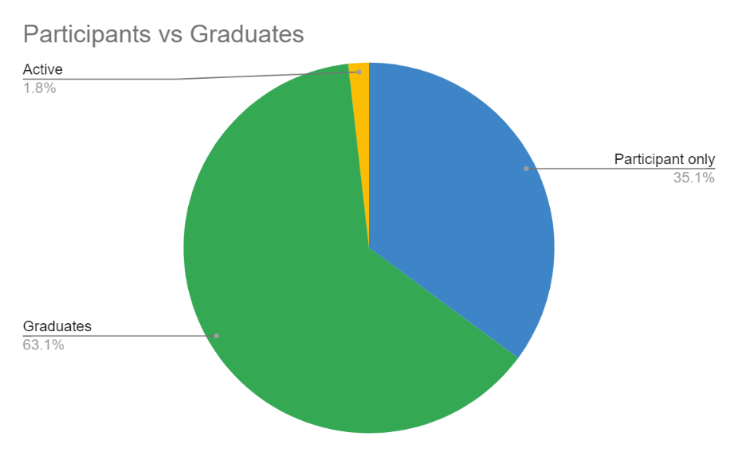
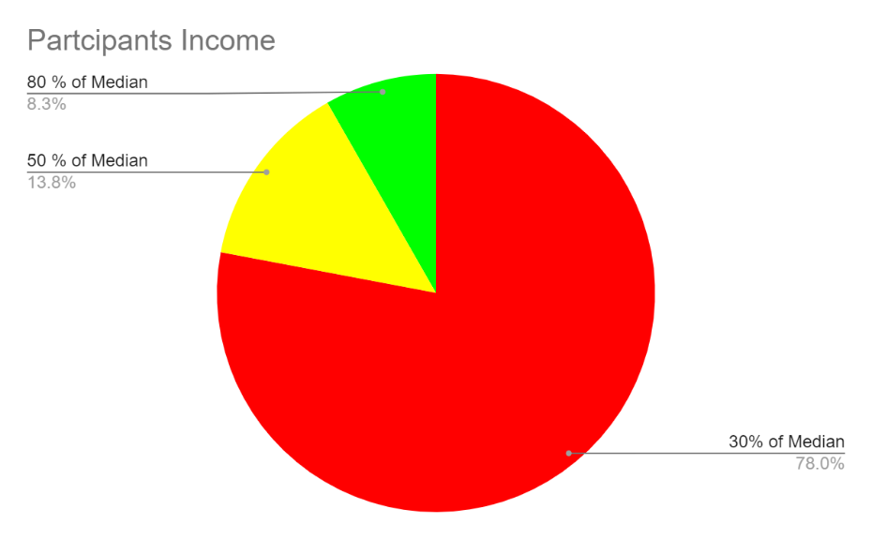
Feedback from Graduate in April 2023:
“When I saw the flier for your class, I decided on a whim to give it a shot. I went in not expecting to learn or hear anything that I hadn’t before, but by the time the first class was over I felt different. I went home and created a budget. I have checked that budget every morning since, to make sure that I am staying within it. I’ve even managed to put $100 into savings from my last check, with a plan to save a LOT more very quickly. The difference between the other times I’ve tried and this one is, without a doubt, you! You gave me permission to make mistakes, to build my budget in a way that works for me. You even managed to make living on a budget feel like a gift I’m giving to myself instead of a sacrifice that I must make. I cannot thank you enough! You’re really changing people’s lives, and I wanted to make sure you got to hear that.”

Student Development:
Student Development (Mentor SGF):
Community Partnership’s Mentor SGF was established to provide students with engaging programs and positive adult role models to promote life skills, social skills, and academic success. Mentor SGF seeks to build confidence, self-awareness, grit, and resilience in students. The primary area of focus is on select Title I schools in the Central and Hillcrest High School feeder patterns. Mentor SGF includes the following programs: Bulldog Basketball Academy, small group mentoring, one-on-one mentoring, after school clubs, and Brother 2 Brother.
In FY23, Mentor SGF:
- Served a total of 1,008 students
- Increase of 60% from FY22 (FY22 had a 49% increase from FY21)
- A volunteer with Mentor SGF shared, “Throughout my life, I have dreamed of finding a solid, impactful way to help the youth in our community. Volunteering with CPO has not only fulfilled that dream, but also ignited many ideas for me to build upon my purpose!”

Bulldog Basketball Academy:
Bulldog Basketball Academy is a mentoring program “disguised” as basketball training. The goal of this initiative is to prepare students for success in school, and life as an adult, while providing quality basketball training. We focus on the importance of hard work as the only way to be successful at all endeavors during their life.
The 5th year of Bulldog Basketball Academy was yet another year of accelerated growth with more students, more locations, and more sessions. We now partner with SPS, The Springfield Dream Center, and The Boys & Girls Club. Student retention in this program is strong, coupled with the increase of new students in each session shows us that this program is making a positive impact on students.

In FY23, Bulldog Basketball Academy:
- Served 263 students
- 99% increase from FY22 (FY22 had an 82% increase from FY21)
- 3 partnerships-SPS, The Springfield Dream Center, The Boys & Girls Club
- 7 locations: Boyd Elementary, Weaver Elementary, York Elementary, Westport K-8, Springfield Dream Center, John B. Hughes Apartments, and The Boys & Girls Club
- 12 sessions, 84 engagement opportunities for students

Students Surveyed:
- 96% said coaches helped them understand the importance of hard work
- 96% said that coaches care about them and want them to succeed
- 95% said they learned to properly introduce themselves
- A Bulldog Basketball Academy partner stated, “We love partnerships like this one because they provide kids with the opportunity to do something fun while also learning life skills that go beyond the sport of basketball and will last them a lifetime.”

Small Group and One-on-One Mentoring:
Mentor SGF provides small group and one-on-one mentoring at 7 SPS locations: Bowerman Elementary, Boyd Elementary, Weaver Elementary, York Elementary, Pipkin Middle School, Reed Academy, and Westport K-8. The focus is on underserved students with a goal of breaking the cycle of poverty that is prevalent in the communities that we serve. We provide consistent, positive role models for students and seek to increase students’ self-esteem, confidence, and motivation to thrive in life.

In FY23, Small Group/One-on-One Mentoring:
- 92 students served
- 207% increase from FY22
- 246 engagement opportunities for students
- The parent of a SPED student said, “We are thankful to have this opportunity for our son. This program has given him confidence to participate in an afterschool club and even perform in the school talent show. This would not have been possible without his participation in mentoring.”

After School Clubs:
Mentor SGF supports after school clubs in the Springfield Public School District and the Willard Public School District. The 10 locations served are: Reed Academy, Pipkin Middle School, Westport K-8, Bowerman Elementary, Boyd Elementary, Weaver Elementary, York Elementary, Willard North Intermediate, and Willard South Intermediate. After school clubs provide unique opportunities for students to learn a new skill, develop confidence, and bond with their teachers outside of a structured classroom. Our support provides teachers with funding to purchase supplies for their club that they would not otherwise receive.

We saw an uptick in the interest of teachers wanting to organize and run after-school clubs this year. This is shown in the increase in both the number of clubs and the number of students who participated in clubs this year.

In FY23, After School Clubs:
- 554 students served
- 110% increase from FY22
- 27 clubs (increase of 50% from FY22)
- 432 engagement opportunities
Students Surveyed:
- 87% reported they felt more confident at school
- 85% said being part of a club helped them learn the importance of hard work
- “CPO has been a godsend. They have helped provide opportunities for my students that otherwise they might not have. I love the CPO team! They are a kid friendly organization. They get it!”

Brother-2-Brother:
Brother-2-Brother is dedicated to ensuring students have the support needed to excel academically, socially, and professionally. This is done through individual middle school, high school, and college chapters in Springfield providing education to career support as well as recognition for the talent, drive, and contributions that these young men make in our community. FY23 marked another year of rapid expansion in Springfield. There are now 15 chapters up and running with the addition of 5 middle school chapters, the Launch HS chapter, and Drury University.

CPO partners with Brother-2-Brother in Springfield to assist in growing and sustaining this important program in our community. We sponsored SAAB Saturday, a monthly event that brings all Springfield chapters together for educational, inspirational, and collaborative opportunities. CPO also sponsored the Brother-2-Brother Citywide Kickoff, which brought together SPS leaders, community partners, SAAB chapter advisors, and students to lay out a plan for the upcoming school year. At the end of the school year, CPO sponsored the Brother-2-Brother Citywide Annual Awards Banquet to celebrate the accomplishments of the Springfield chapters throughout the school year. CPO also provided financial support through purchasing suits for students in need of assistance. We provided direct support to the Central, Hillcrest, Pipkin, Reed, and Westport chapters.

CPO also organized and advised the Brother-2-Brother City-Wide Council. This student led council brings together one representative from each HS and College chapter once a month. We worked with the 2 student leaders of the council to help them set agendas, organize meetings, and effectively lead council meetings.

FY23 Highlights:
- 167 students participated in local chapters
- 15 active chapters in Springfield
- 27 suits purchased for students through our black suit initiative
- CPO presented iPads to graduating seniors
- 2-$500 Leadership Awards given to students through the Francine and Wes Pratt endowment
- Financially sponsored all major Brother-2-Brother events in Springfield

Community Mentoring and Supportive Services Program:
Our Community Mentoring and Supportive Services Program is designed to provide mentoring and support to justice-involved youth committed to Missouri’s Division of Youth Services (DYS). The program works in partnership with the Division of Youth Services’ local Service Coordinator team to determine if youth are a good match for receiving one-on-one mentoring. The program partners with the Excel Resource Center, one of the state’s unique day treatment facilities, to offer after-school group mentoring activities and family events. Other support services are provided through community resource referrals, fulfilling DYS requests for youth needs, and providing family engagement opportunities. The program works to meet youth where they are in the treatment process and support those who support them.
Mentoring highlights:
- 18 youth served through individual mentoring
- 54 referrals made to 16 different community resources
- Youth worked on everything from college entrance applications, job applications, driver’s permits, budgeting, and life skills.
- Mentors and mentees had tough conversations about things like hygiene, family conflict, integrity, and graduating from high school. Each youth received support in their pursuit to find healthy hobbies and recreational opportunities.
- Mentored youth were helped with work clothes, groceries, household items, hygiene products, gas cards, and family engagement.
- One youth is receiving a monthly phone card so he can maintain contact with Foster Adopt Connect, as he transitions to adulthood.
- One youth told his mentor, after receiving help with work clothes, “I have never felt so supported.”
After School Activities:
- The mentoring program facilitated 81 after-school activities at the Excel Resource Center.
- These group mentoring opportunities allowed students to do STEM projects like build Bluetooth speakers, ukuleles, and candy vending machines. The youth opened geodes, did basic forensic science, and experimented with capillary action. They learned life skills by making pizzas from scratch and homemade apple jelly. Students were exposed to silent films and monthly culture boxes. They got creative through tie-dying shirts, painting, and making fairy lanterns. Other times, we simply had fun with activities like bowling, Hot Wheels races, and eating lots of snacks!
Family Night:
- Co-facilitated 9 events (7 Family Nights and 2 Holiday Luncheons) at the Excel Resource Center
- The events ranged in attendance from 26-50 individuals served.
- These themed events included dinner, conversation, gift bags, and the occasional activity.
- This year we included a Halloween costume contest, Santa’s Sweet Shop, and special ribbon cutting for the newly renovated garden.
Our strong partnership with the Division of Youth Services helps us meet the needs of justice-involved youth and their treatment goals in a variety of ways.
Needs filled:
- Fulfilled Service Coordinator requests for 3 bikes, 3 beds, football shoes, and gas cards.
- Helped with 2 graduation celebrations for youth who worked especially hard for their diplomas.
- Supported both Domestic Violence Awareness Month and Crime Victims’ Rights Week awareness through awareness and activities.
- Continued support of Excel’s clothing bank and garden project.

